

*ASSIGNMENT 1*

QN1 Create a database named people_education.

Qn2

 Show that the database has been created

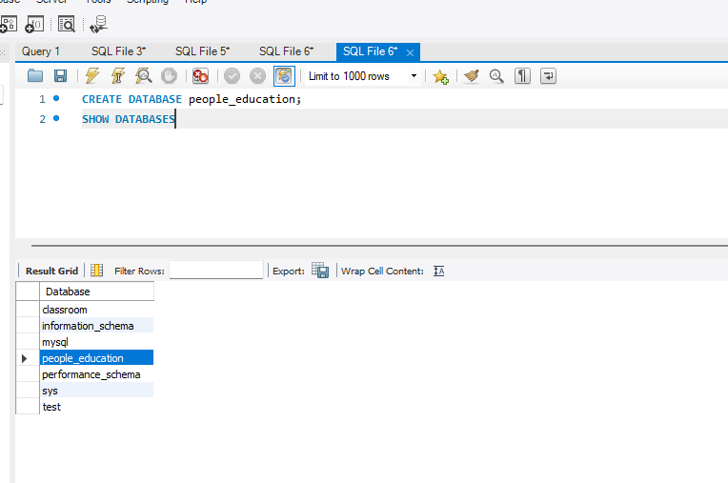

QN 3 a

Create the following tables. Be sure to make the columns the correct data types:

a)  Create a table named people_info.

It should have the following columns: name, age, high school attended, and height.

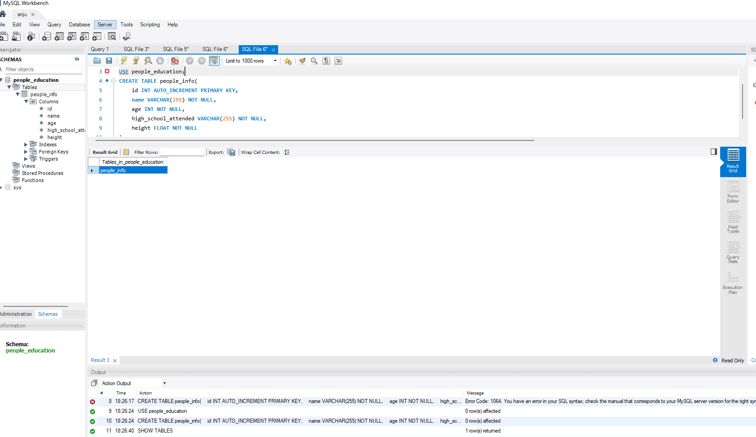

Qn 3b

Create a table named school_info.

It should have the following columns: school name, zip code.

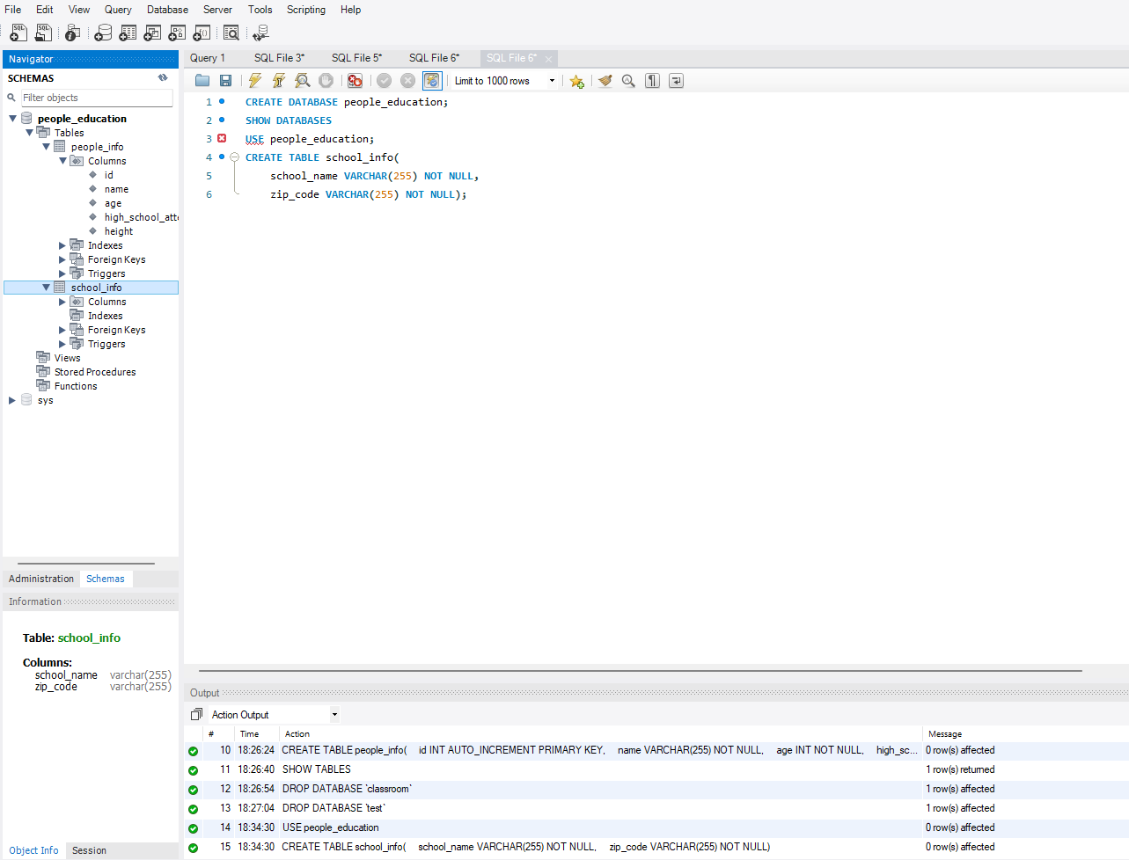

Qn3c

 Create a table named school_mascot.

It should have the following column: school name, the school mascot.

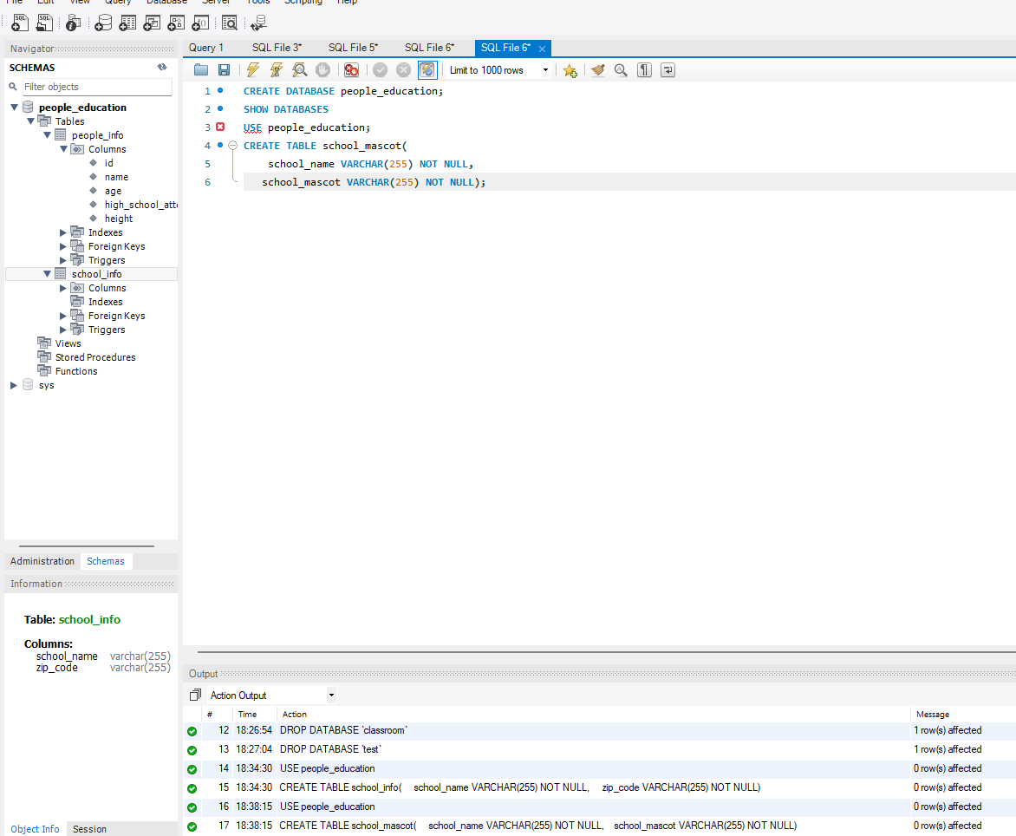

Qn 4

Show all tables using the show tables; command.

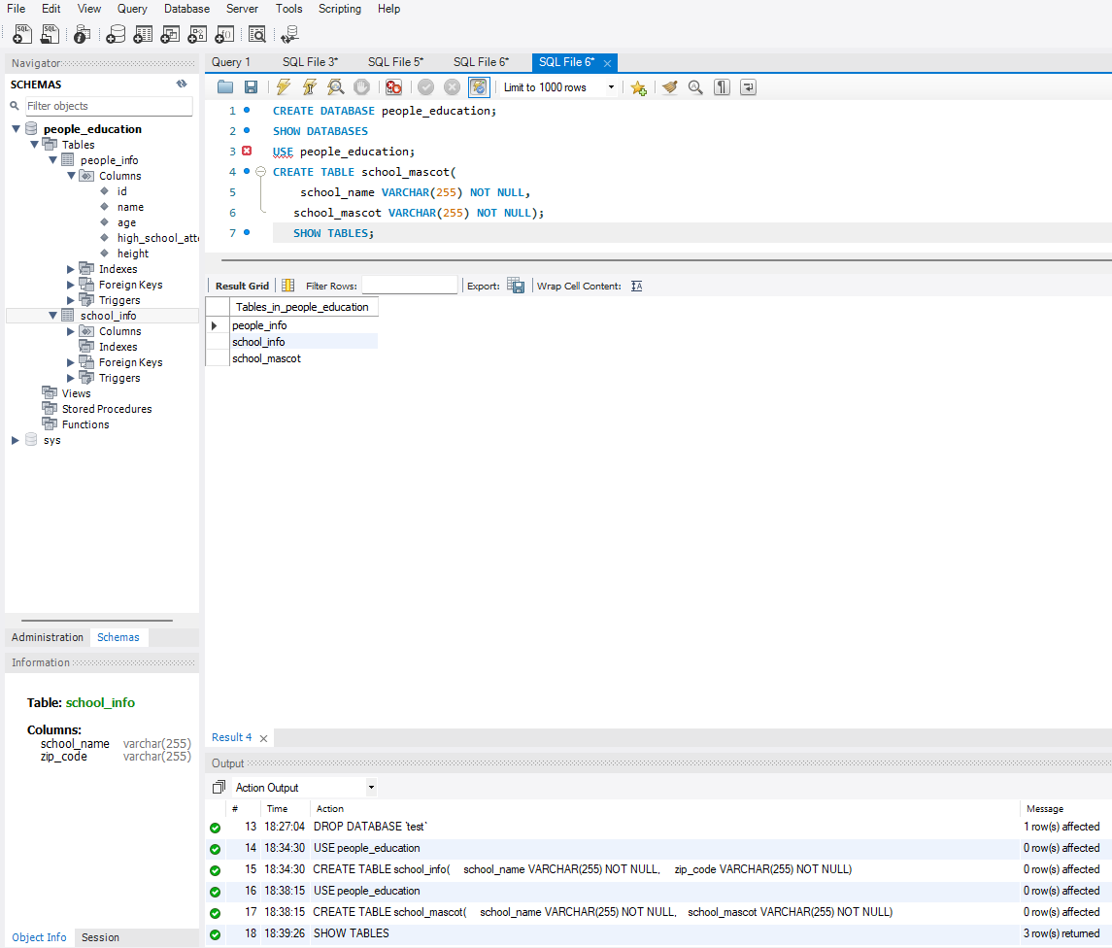

Qn 5

Delete the school_mascot table.

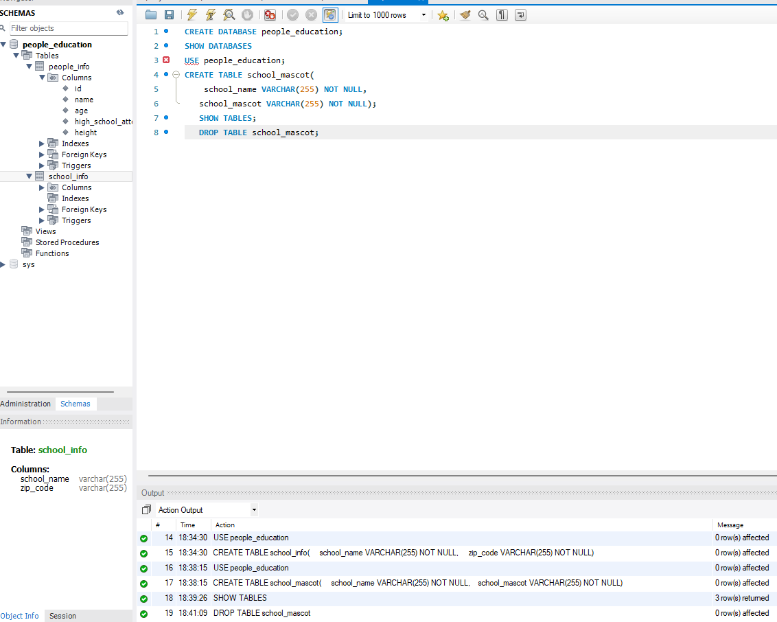

Qn6

“Poll” at least 4 different people and record the information about them:

Name, age, high school name, height (in meters), and high school zip code.

For each person, populate the people_info tables with some made-up data.

